BibTeX:  
@INPROCEEDINGS{8038469,   
author={J. Burke},   
booktitle={2017 26th International Conference on Computer Communication and Networks (ICCCN)},   
title={Browsing an Augmented Reality with Named Data Networking},   
year={2017},   
volume={},   
number={},   
pages={1-9},   
abstract={Augmented and virtual reality (AR and VR) are entering the consumer market, and attracting substantial attention from content creators. However, delivering AR and VR experiences using existing IP networks presents significant challenges that tend to force creators into "stovepipe" solutions, in contrast with the openness of the early World Wide Web, which led to its widespread content revolution. Taking advantage of multiple network interfaces and providing resilience to intermittent connectivity in mobile scenarios are difficult, as is handling trust for experiences built up from the content of heterogeneous providers. Additionally, streaming AR and VR content, including video components, must be user-navigable across multiple dimensions. This paper explores opportunities for an augmented reality web using Named Data Networking (NDN), a proposed future Internet architecture in which the network forwards intrinsically secure data packets directly based on application-defined names. By providing web semantics at packet granularity, NDN enables the success of the web to be pursued for low-latency, high-granularity, and context-dependent media in AR. The paper outlines emerging media types that could be part of a new AR browsing experience, briefly introduces NDN, describes benefits the architecture should provide via an example browser design, and enumerates related open research challenges.},   
keywords={Augmented reality;Browsers;Media;Navigation;Streaming media;Three-dimensional displays;Two dimensional displays},   
doi={10.1109/ICCCN.2017.8038469},   
ISSN={},   
month={July},}

**Bibliography**

Augmented reality in the field of human interaction has been a most attractive concept in the recent past. In addition to creating user experiences, AR is also entering in the field of consumer market, and attracting substantial attention from content creators.

By using the current IP networks, deploying AR techniques poses a significant challenge leading to usage of “stovepipe” solution, in contrast with the openness of the early World Wide Web, which led to its widespread content revolution.

The current article interests me since the authors have explored opportunities for an augmented reality web using Named Data Networking (NDN), a proposed future Internet architecture in which the network forwards intrinsically secure data packets directly based on application-defined names.

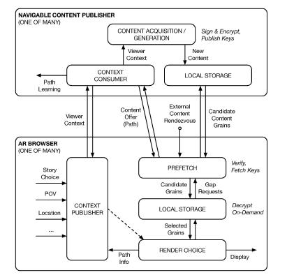

**References:**

* <http://ieeexplore.ieee.org.libproxy.uml.edu/document/8038469/citations>
* UML Library
* IEEE Webpages
* [Performance of multimedia applications with IPSec tunneling](http://ieeexplore.ieee.org.libproxy.uml.edu/document/1000374)
* [SPEM online rate control for real time streaming video](http://ieeexplore.ieee.org.libproxy.uml.edu/document/1000361)

"This is entirely my own work, except as disclosed in the documentation. I gave help to the following persons:   
None  
Signed Kiran C Shettar"